In MATLAB run

ephysanalysis (0,1,0)

Select your .abf files and then pick which kind they are...So the options for the analysis type is as follows:

Full AHP analysis: for post-burst AHP analysis from orthodromically elicited APs

Post-Burst AHP only: for post-burst AHP analysis from current injection elicited APs

Example file with 25 current injection induced action potentials and a post-burst AHP.

1. Select timing where baseline potential should be measured.
2. 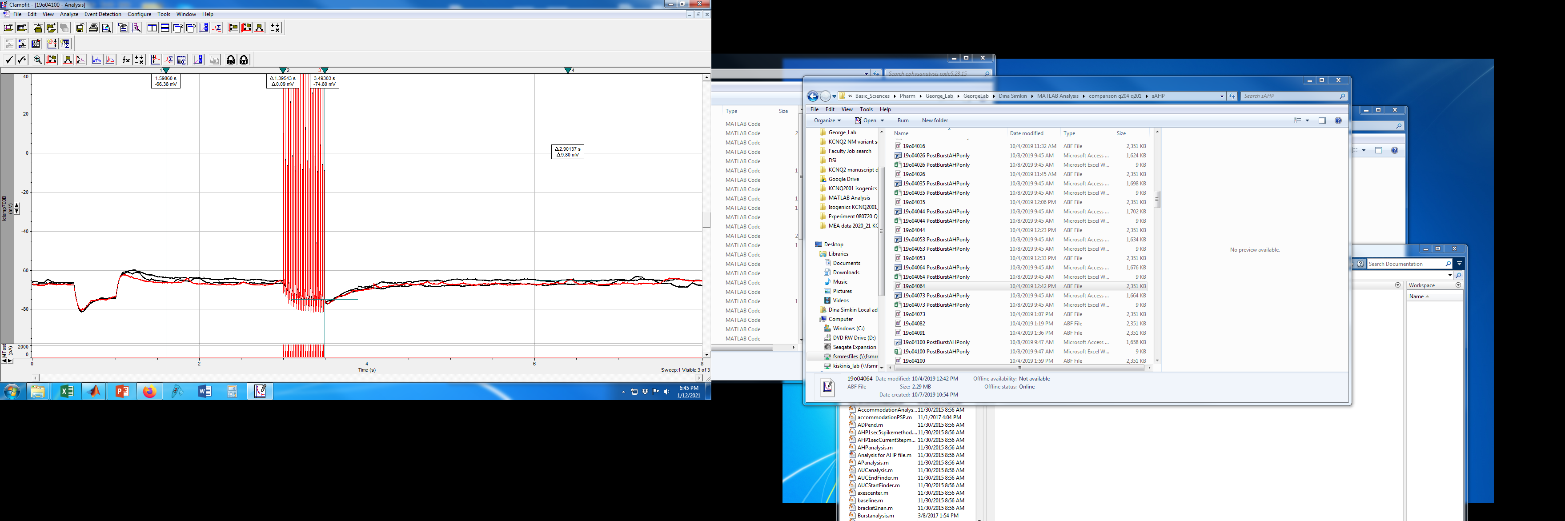Select timing of the end of stimulation (ie end of current pulse train)

Accommodation: This is for action potential wave form analysis on ramps This is what you use for basic analysis

*AP Analysis: This is for action potential wave for orthodromically elicited AP*

*Drug Spikes: This is for AP files that have weird spikes with spontaneous activity in your desired baseline*

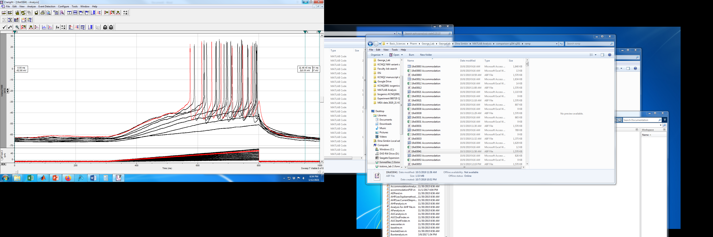*Accommodation with PSP: This is for action potential wave for orthodromically elicited AP and EPSP or IPSPs with subthreshold stimulation*

1. Select timing where baseline potential should be measured.
2. Input your dvdt threshold.

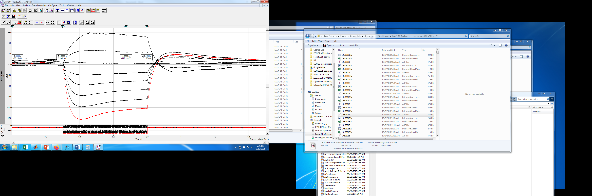I/V Analysis: For analysis of input resistance and sag

New Style Accommodation: For analysis of accommodation and counting spikes

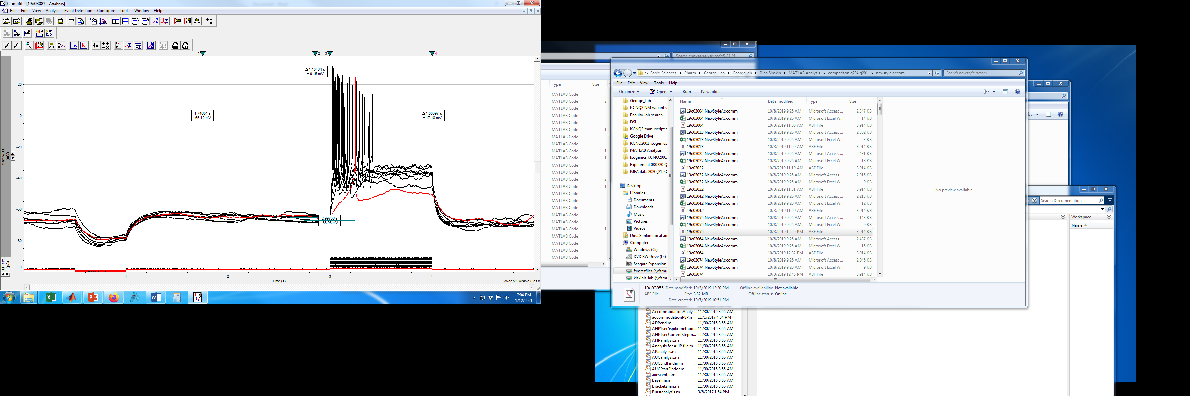Accommodation with PSP: This is for action potential wave for orthodromically elicited AP

AreaUnderCurve Spikes: For ADP analysis

Burstanalysis: For counting spikes in a train pulse